Bulk Image Resize Manager

Path: C:\Program Files (x86)\Bulk Image Resizer

Type: bulk..

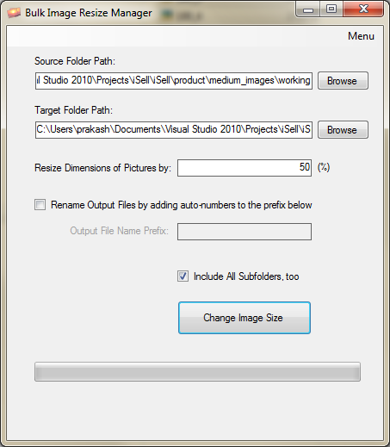
Resized files have extension .jpg. Make sure the extension changed to *.gif.
